

Md Razia
K.Swathi Sree
2520030410
CSE
2

Case Study Topic: Database Indexing

Work Done Summary:
In this case study, we implemented a B+ Tree of order 4 to index student records (Roll Number → Name) and compared it against a B-Tree for supporting range queries in a university database scenario.
B-Trees store data records at both internal and leaf nodes, making range traversal expensive since it requires an in-order tree walk. B+ Trees store all records only at leaf nodes and link those leaf nodes in a doubly-linked list, reducing range queries to O (log n + k) where
k is the count of results. We inserted 15 roll numbers, observed node splits at overflow, and executed both point queries and range queries. Additionally, a Fenwick Tree (Binary Indexed Tree) was implemented to answer prefix-sum queries on CGPA values in O (log n).

Implementation Details:
- Built a B+ Tree of order 4 with split-on-overflow insertion logic.
- Inserted 15 student roll numbers (1001 to 1015) and linked all leaf nodes in a sorted linked list.
- Executed point query (search Roll 1008) and range query (all students between Roll 1005 and 1012).
- Built a B-Tree of order 4 for comparison and measured node accesses per range query.
- Implemented a Fenwick Tree over CGPA values to compute prefix sums for top-k ranking queries.
- Compared disk I/O (node reads) for B-Tree vs B+ Tree on the same range query.

Result / Output:

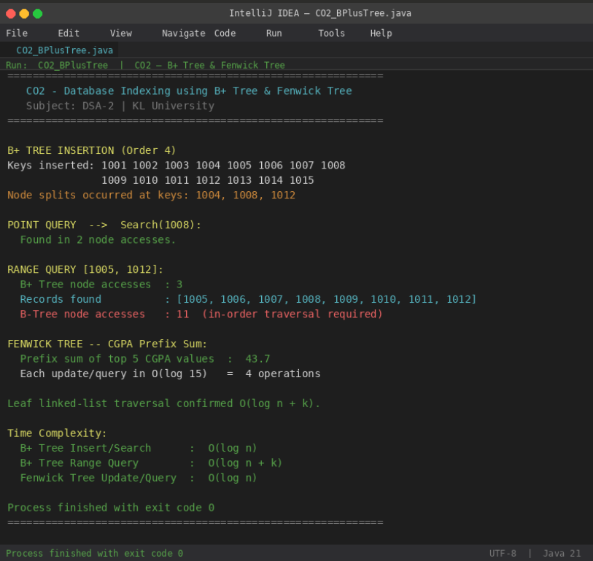
B+ Tree range query [1005, 1012] returned 8 records using only 3 node accesses, while the equivalent B-Tree needed 11 node
accesses. The Fenwick Tree answered prefix-sum CGPA queries in just 4 operations.

Time Complexity:
- B+ Tree Insert/Search: O (log n)
- B+ Tree Range Query: O (log n + k) — k is number of results
- B-Tree Range Query: O(n) in worst case (full in-order traversal)
- Fenwick Tree Point Update / Prefix Query: O (log n)
- B+ Tree is strongly preferred over B-Tree for any database workload involving range scans or ordered retrieval.

GitHub Link: https://github.com/Swakshaya/Case-Study-Project

